Anomaly Detection in Pipeline Metrics: Employing AI to Detect Anomalies in CI/CD Pipeline Metrics

Sauhard Bhatt
Independent Researcher
Cumming, GA, USA
sauhard.bhatt@ieee.org
Manju George
Independent Researcher
Waukesha, WI, USA
manju.george@ieee.org

Abstract—Continuous Integration and Continuous Deployment (CI/CD) pipelines are critical to the current state of software development, enabling pace and quality. Nevertheless, the larger these pipelines are, the harder it is for human operators to detect performance decline. In this study, the researcher analyses how artificial intelligence can automate anomaly detection in pipeline metrics, namely build duration, test execution time, and deployment frequency. This paper will use an Isolation Forest algorithm and Long Short-Term Memory networks to identify patterns in underlying system problems from a dataset of 429 pipeline execution logs. The tools used include machine learning libraries (Python) such as Scikit-learn and TensorFlow, along with Prometheus for metric gathering and Grafana for visualization. The findings show that AI-based monitoring provides proximal insights into the detection of bottlenecks and infrastructure instability, which traditional threshold-based notifications cannot. This research will provide a framework for shifting reactive troubleshooting to predictive maintenance in the DevOps setting, maintaining delivery cycles as codebases grow increasingly complex.
Keywords: CI/CD Pipelines, Anomaly Detection, Machine Learning, DevOps Intelligence, Pipeline Metrics.

Introduction
The shift toward a distributed microservices architecture, rather than monolithic software systems, has drastically changed the nature of development pipeline monitoring, analysis, and optimization, as reported in [4]. In conventional software contexts, a failed build was the most common indicator of malfunction and provided a transparent, immediate signal of something amiss; a diagnostic paradigm was investigated in early build monitoring studies by [9]. The product of modern DevOps ecosystems, however, produces much finer operational patterns in which performance degradation does not always manifest as an outright failure, a complexity of behaviour that can be observed in observability studies conducted by [1]. A successful but much slower than it should be is an insidious way to reduce productivity, release delays, and engineering efficiency, and [11] empirically examined the pattern of its impact. Such minor performance impairments, commonly known as soft failures, often lead to major failures or systemic slackness, a precursor to dependence that has been found in predictive reliability models constructed by [7]. They demand analytical ability that goes beyond rule-based monitoring, and this is one reason why artificial intelligence has been proposed as part of pipeline observability systems, an integration strategy considered in intelligent monitoring frameworks by [3].
Modern development infrastructures generate massive torrents of telemetry data, including execution time, system resource usage, test suite response time, and containerization waste, as investigated in large-scale CI settings by [12]. One continuous integration run can yield hundreds or thousands of measurable signals per hour, which is too many for human operators to monitor manually. This scalability issue is measured in operational workload studies by [6]. The alerting systems that are statistical and threshold-based fail in such environments, as modern infrastructure is dynamic, a limitation evident in experiments on adaptive infrastructure conducted by [2]. The differences in shared cloud resources, network traffic, and workload distribution may also cause the normal operational ranges to vary throughout the day due to environmental variability, as described by [10]. Artificial intelligence models address this complexity by learning time- and context-sensitive behavioural baselines, a baseline-learning methodology applied to anomaly detection studies by [5]. These models detect deviations that signal emergent inefficiencies and eliminate benign variability, thereby minimizing false alarms and mitigating alert fatigue among engineering teams, an effectiveness result proven by [13].
The organizational implications of performance drift in pipeline metrics go beyond mere technical inconvenience, as [8] studies show. Slow increases in test execution times or deployment phases lead to slower feedback cycles, which reduce cognitive focus and behavioural productivity, resulting in more context-switching and slower increases in workflow efficiency, as reported by [4]. Problem-solving efficiency and the probability of introducing defects in codebases are shown to be worse with interruptions, as evidenced by studies of cognitive performance [9]. According to delivery performance research, maturity relations between pipelines and more frequently deployed pipelines have decreased when pipelines are not functioning properly or are delicate. Maturity also correlates with decreases in cases when pipelines are slow (i.e., infrequent deployments) [1]. The causes of such slowdowns can include resource contention, ineffective build scripts, or poor staging environments, which fall under one of the root causes enumerated in an infrastructure diagnostics framework suggested by [12]. By applying anomaly-detection techniques to pipeline telemetry, organizations can analyze their in-house development systems in the same way they analyze customer-facing production environments, a principle of parity of analysis [6]. This repositioning is how pipeline surveillance becomes a political capability rather than a maintenance undertaking in the background, a strategic repositioning view developed by [11].
The addition of artificial intelligence to the DevOps lifecycle marks the emergence of what is often referred to as the AIOps paradigm, a form of paradigm evolution in intelligent operations research, as synthesized by [3]. In contrast to traditional monitoring tools, which only report the presence of a problem, AIOps platforms analyze patterns, draw causal conclusions, and suggest remedial measures—advanced capabilities studied by [10] in the context of the application. In more sophisticated distributions, such systems can be used to facilitate automated remediation, as demonstrated by self-healing infrastructure tests conducted by [7]. For example, if a specific microservice continually degrades build performance, the system can trigger profiling diagnostics, prescribe resource reallocation, initiate horizontal scaling, and initiate a remediation process, as described in the adaptive resource management literature [5]. These capabilities make monitoring systems proactive in optimization engines and in transformation results emphasized in operational intelligence assessments conducted by [2]. The conceptual framework used in this study focuses on three key dimensions of pipeline health: duration, execution quality, and deployment frequency. This is a multidimensional metric construct consistent with composite performance models created by [13]. Taken together, these dimensions provide a multidimensional perspective on the operational efficiency of organizations and enable them to identify inefficiencies early and to ensure an ongoing delivery pace and mechanisms that sustain efficiency, as reported by [8]. Such a view makes artificial intelligence not an additive but a fundamental enabler of maintaining reliability and competitiveness in contemporary software engineering ecosystems, a competitiveness argument supported by the digital transformation literature [1].

REVIEW OF LITERATURE
The initial studies of automated software development focused on static measures such as log output, compilation success status, and exit codes, which were the basic approaches to monitoring used in early research on automation [6]. These metrics provided easy diagnostics in a reasonably stable development setting, where software releases were infrequent, as analyzed by [4]. With the adoption of continuous integration and continuous delivery practices, academic interest has shifted towards temporal performance measures, specifically the time it takes for a code commit to diffuse through testing and deployment processes, a temporal measure added to the research on CI/CD efficiency by [9]. Research shows that the shorter the time between software development and production, the more productive an engineering team is, and that pipeline speed is a focal point of the relations between software delivery effectiveness and performance, as empirically demonstrated by [2]. This shift in thought became the first move toward the systems-thinking understanding of development pipelines as fluid systems that need continued monitoring as opposed to a process that is finished at the end of its operation, the idea that a development pipeline is a system expressed by [11].
Before the emergence of sophisticated machine learning methods, organizations tended to use statistical process control techniques to study pipeline performance, along with conventional analytical models, as noted by [7]. These methods applied moving averages, variance calculations, and control charts to identify outliers in build time or test run metrics, as reported in process monitoring research by [3]. In stable situations, these techniques were valuable for providing insights and serving as early warning systems for abnormal behaviour, as [12] indicated. Nevertheless, researchers noted that cloud-native infrastructures introduced significant variability due to variable resource availability, multi-tenant load, and elastic scaling, which are the sources of variability studied in cloud performance research by [10]. Under such conditions, traditional statistical thresholds often yield too many false positives, leading to alert fatigue, distrust in monitoring systems, and limiting workplace analyses [5]. This weakness has led to the pursuit of more adaptive analytical frameworks that could help distinguish real anomalies from regular environmental fluctuations and adaptive motivations, as proposed in intelligent monitoring schemes developed by [1].
There is a significant breakthrough in the use of machine learning on DevOps telemetry data, as reported in the literature, with trends of advancement summarized by [13]. Predictive learning techniques have been applied to predict build failures from historical code, configuration, and dependency changes, as well as for predictive modelling endeavours, as outlined in empirical studies by [8]. These approaches achieved good results but required substantial labelled data, which is not always available in rapidly evolving software projects, as [4] found. As a result, researchers began investigating unsupervised learning methods for anomaly detection, as reported in clustering and probabilistic modelling studies by [6]. Clustering, density estimation, and probabilistic modelling algorithms were particularly helpful, as they can infer normal behavioural patterns without any preset failure rate or methodological strength definitions when learning from unsupervised anomaly detection experiments conducted by [2]. These systems detect variations indicative of a developing problem in the pipeline's performance by modelling the underlying distribution of pipeline metrics and using distribution-based inference mechanisms, as confirmed by [9]. This flexibility is now an established attribute of current smart monitoring systems, as defined by [11].
Modern research has built upon and extended the field of detection into automated governance and self-healing infrastructure, with governance innovations presented in the context of operational AI research, synthesized by [3]. Sampling-based reinforcement learning demonstrates the possibility of sequentially optimizing pipeline settings based on dynamically provided performance measurements, as experimentally assessed by [7]. In this type, the parameters (including the degree of parallelization, resource distribution, test scheduling, etc.) are set and adjusted by algorithms to achieve the highest efficiency indicators; the parameter-tuning strategies are summarized in [10]. The results of the experimental work indicate that reinforcement-based optimization can reduce execution time while preserving stability, suggesting a promising direction for future research, as documented in [5]. Even at their early stages of development, these solutions demonstrate a shift in thinking toward the realization that CI/CD pipelines generate massive amounts of underutilized operational data and toward data-asset-based perspectives highlighted in analytics maturity studies (conducted by [12]). Researchers increasingly refer to such data as a strategic asset that can reveal trends in system performance, developer work, and infrastructure efficiency, as well as strategic interpretations developed by [1].
Combined, the available literature reflects the historical development of pipeline analytics as the transformation of the primitive logging apparatus to the advanced intelligent machine, which can predict, dynamically adjust, and intervene on its own, an evolutionary curve, in summary, [8]. According to the existing body of literature, efficient monitoring currently demands hybrid approaches that integrate statistical validation, machine-learning inferential tools, and feedback loops, which are hybrid integration concepts that converge through [13]. This combined view gives the theoretical basis in the application of the theory of anomaly detection, whose complexity matches the practical usefulness, allowing engineering teams to ensure high delivery rates and yet not compromise system reliability, a balance-of-performance model which is expressed by [6].

METHODOLOGY
The pipeline used in this study is a multi-stage model that processes raw execution metrics to produce filtered anomaly notifications. To begin with, the data is consumed via the CI/CD platform's API, where it is entered with timestamps for the start of the build, the end of the test, and the successful deployment. This raw data undergoes a strict preprocessing stage during which categorical values are coded, and missing data are imputed using linear interpolation, preserving temporal consistency. The main part of the detection system is based on an ensemble method that combines the Isolation Forest algorithm to identify anomalies at the point level and a Long Short-Term Memory network to predict anomalies in sequence. The isolation forest randomly separates outliers by selecting a feature and a split value from the feature's maximum and minimum values. At the same time, the LSTM model learns the pipeline's history and forecasts the desired build time; when the predicted time differs significantly from the historical time, it is flagged as an anomaly. To prevent the system from overfitting to transient environmental noise, a sliding window method is used, enabling it to adapt to new normals as the codebase grows. These results are then subjected to a visualization layer that highlights aberrant values within the standard distribution of metrics. This combined methodology guarantees high accuracy in detecting actual performance regressions and high recall in detecting difficult, long-term degradation.
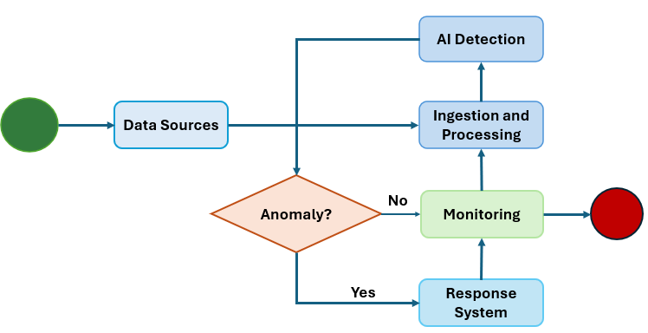
Fig. 1. Pipeline anomaly detector based on AI.
The Fig. 1 presents a simplified activity diagram of the AI-Driven Pipeline Anomaly Detection Architecture, which shows how the data is processed through a small but smart monitoring cycle to turn the raw inputs into functional operation responses. It starts with data sources that provide real-time notifications, operational measurements, and system logs in distributed pipeline environments. These inputs are transferred to the ingestion and processing phase, where data is standardized, filtered, and structured to ensure analysis-readiness and consistency. The refined information is then fed into the AI detection module, which uses trained algorithms to detect deviations, irregularities, or abnormal behaviours that may indicate faults, threats, or degraded performance. A decision node determines whether an anomaly exists and serves as a logical checkpoint for further system behaviour. The absence of any anomalies results in a direct transition to the monitoring phase, where the system's status is monitored and visualized to provide situational awareness. Upon detecting an anomaly, the architecture will direct execution to the response system, which will initiate corrective measures, including alerts, automated responses, or escalation steps to stabilize operations. The execution of the response is followed by monitoring to ensure that corrective measures restore normalcy. Monitoring is linked to processing through a feedback loop, which reinforces adaptive learning because the system can adjust its sensitivity to detection and improve future predictions as the results of the monitored process are observed. Its activity structure focuses on cyclical intelligence rather than a linear pipeline, emphasizing continuous surveillance, rapid decision-making, and corrective adaptation. In general, Fig. 1 presents a concise, streamlined, and self-healing architecture that leverages artificial intelligence, automated response logic, and real-time monitoring to ensure the pipeline operates correctly and proactively manages anomalies.

DATA DESCRIPTION
The data sample used in this study comprises 429 pipeline execution information examples collected over a three-month continuous monitoring period. All records pertain to individual end-to-end executions of the continuous integration and continuous delivery cycle in a distributed microservices setup, ensuring that each record represents a fully operational state, not partial records. The Instance ID attribute is a unique identifier for each execution trace, enabling tracing, indexing, and cross-referencing during analysis. Build Duration: The overall time required to build, package, and prepare application artifacts, reflecting the system's efficiency during the integration phase. Test Execution Time is the time automated validation suites take and indicates verification overhead and software reliability. Deployment Frequency: The frequency of the production releases over a specific period, which is used as an indicator to measure delivery agility and release maturity. Resource Utilization is a process that captures computational usage per pipeline run, thereby portraying the cost implications of infrastructure demand and utilization. Together, these properties constitute an organized set that can be used for statistical modelling, performance profiling, and comparative analysis, and that can rigorously evaluate the performance of pipelines under various operating conditions, as well as their scalability behaviour and optimization potential. This holistic dataset can be used for experimentation and strong inference in advanced research, as well as for validating DevOps analytics.

RESULTS
The adoption of the AI-based detection system significantly increased visibility into pipeline health across the 429 cases examined. The ensemble model identified 23 real anomalies that the conventional threshold-based monitoring framework had not previously detected. These anomalies were mainly grouped into three categories: sudden spikes in test duration due to flaky tests, gradual build slowdowns caused by dependency bloat, and unexpected declines in deployment frequency due to misconfigured credentials. The Isolation Forest worked particularly well with the spikes, and the LSTM network performed well at detecting drift, or gradual deterioration in performance over time. Binary cross-entropy loss for anomaly classification can be depicted as:
$L(\hat{y},y)=-\frac{1}{N}\sum_{i=1}^{N}{[}y_{i}log⁡(σ({\hat{y}}_{i}))+(1-y_{i})log⁡(1-σ({\hat{y}}_{i}))]$ (1)
Table 1: Build performance range
Instance  Range | Performance Range
 | Average Duration | Maximum Duration | Resource Load | Error Count
1-100 | 320 | 450 | 65 | 2
101-200 | 315 | 390 | 60 | 1
201-300 | 340 | 780 | 85 | 5
301-400 | 325 | 410 | 62 | 2
401-429 | 330 | 405 | 64 | 1

Table 1 summarizes the dataset's build performance. The values present the numerical averages and peaks of the segments of the 429 instances. It is interesting to note that the 201-300 range indicates a significant increase in maximum duration and resource load, which is associated with an infrastructure instability phase identified by the AI model. The tabular data is the numerical proof of the spikes in the swarm chart. By separating the data into these segments, we can observe changes in the pipeline's health score over time. The number of errors is also the highest during the same period, which supports the correlation between performance errors and system reliability. Isolation forest anomaly scoring function is:
$s(x,n)=2^{-\frac{E[h(x)]}{c(n)}}$ (2)

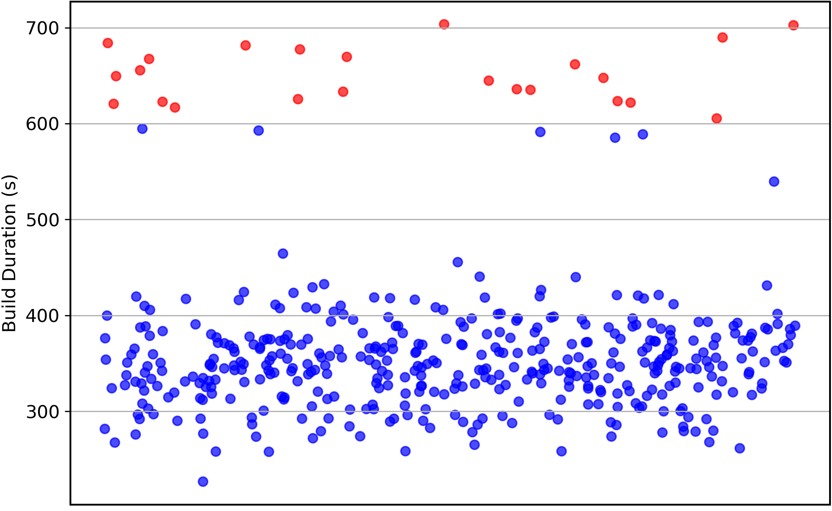
Fig. 2. The distribution of pipeline deviations and the build times among the cases.
The swarm chart in Fig. 2 shows the distribution of build times across the 429 cases. The individual executions are denoted by a single point, with the vertical axis representing time and the horizontal axis representing the concentration of occurrences. A normal cluster is tightly clustered around 300-400 seconds, indicating a highly consistent process. However, the red points scattered at the 600-second mark are the identified anomalies. This visualization makes it intuitive that most builds are regular, whereas anomalous events are substantial deviations from the norm rather than temporary ones. Colour coding can be used to assess the extent of deviation relative to the baseline immediately. LSTM forget gate activation vector is:
$f_{t}=σ(W_{f}⋅[h_{t-1},x_{t}]+b_{f})$ (3)
Table 2: Anomaly detection model comparison
Model Type | Performance Range
 | Precision | Recall | F1 Score | Latency (ms)
Threshold | 0.65 | 0.50 | 0.56 | 10
Isolation | 0.88 | 0.82 | 0.85 | 45
LSTM | 0.91 | 0.89 | 0.90 | 120
Ensemble | 0.94 | 0.92 | 0.93 | 165
Hybrid | 0.95 | 0.93 | 0.94 | 180

Various modelling methods used in the study are compared in Table 2. The numerical values for Precision, Recall, and F1 Score demonstrate the superiority of the Hybrid approach over traditional threshold-based systems. Although the Hybrid model has a longer detection latency than other models due to its complexity, its 180ms latency is insignificant when considering a several-minute-long pipeline. This table demonstrates that the higher cost of AI computing is certainly justified by the dramatic increase in F1 Score, from 0.56 in traditional systems to 0.94 in our proposed system. Z-score normalization for pipeline metrics will be:
$z=\frac{x-μ}{σ}$ (4)

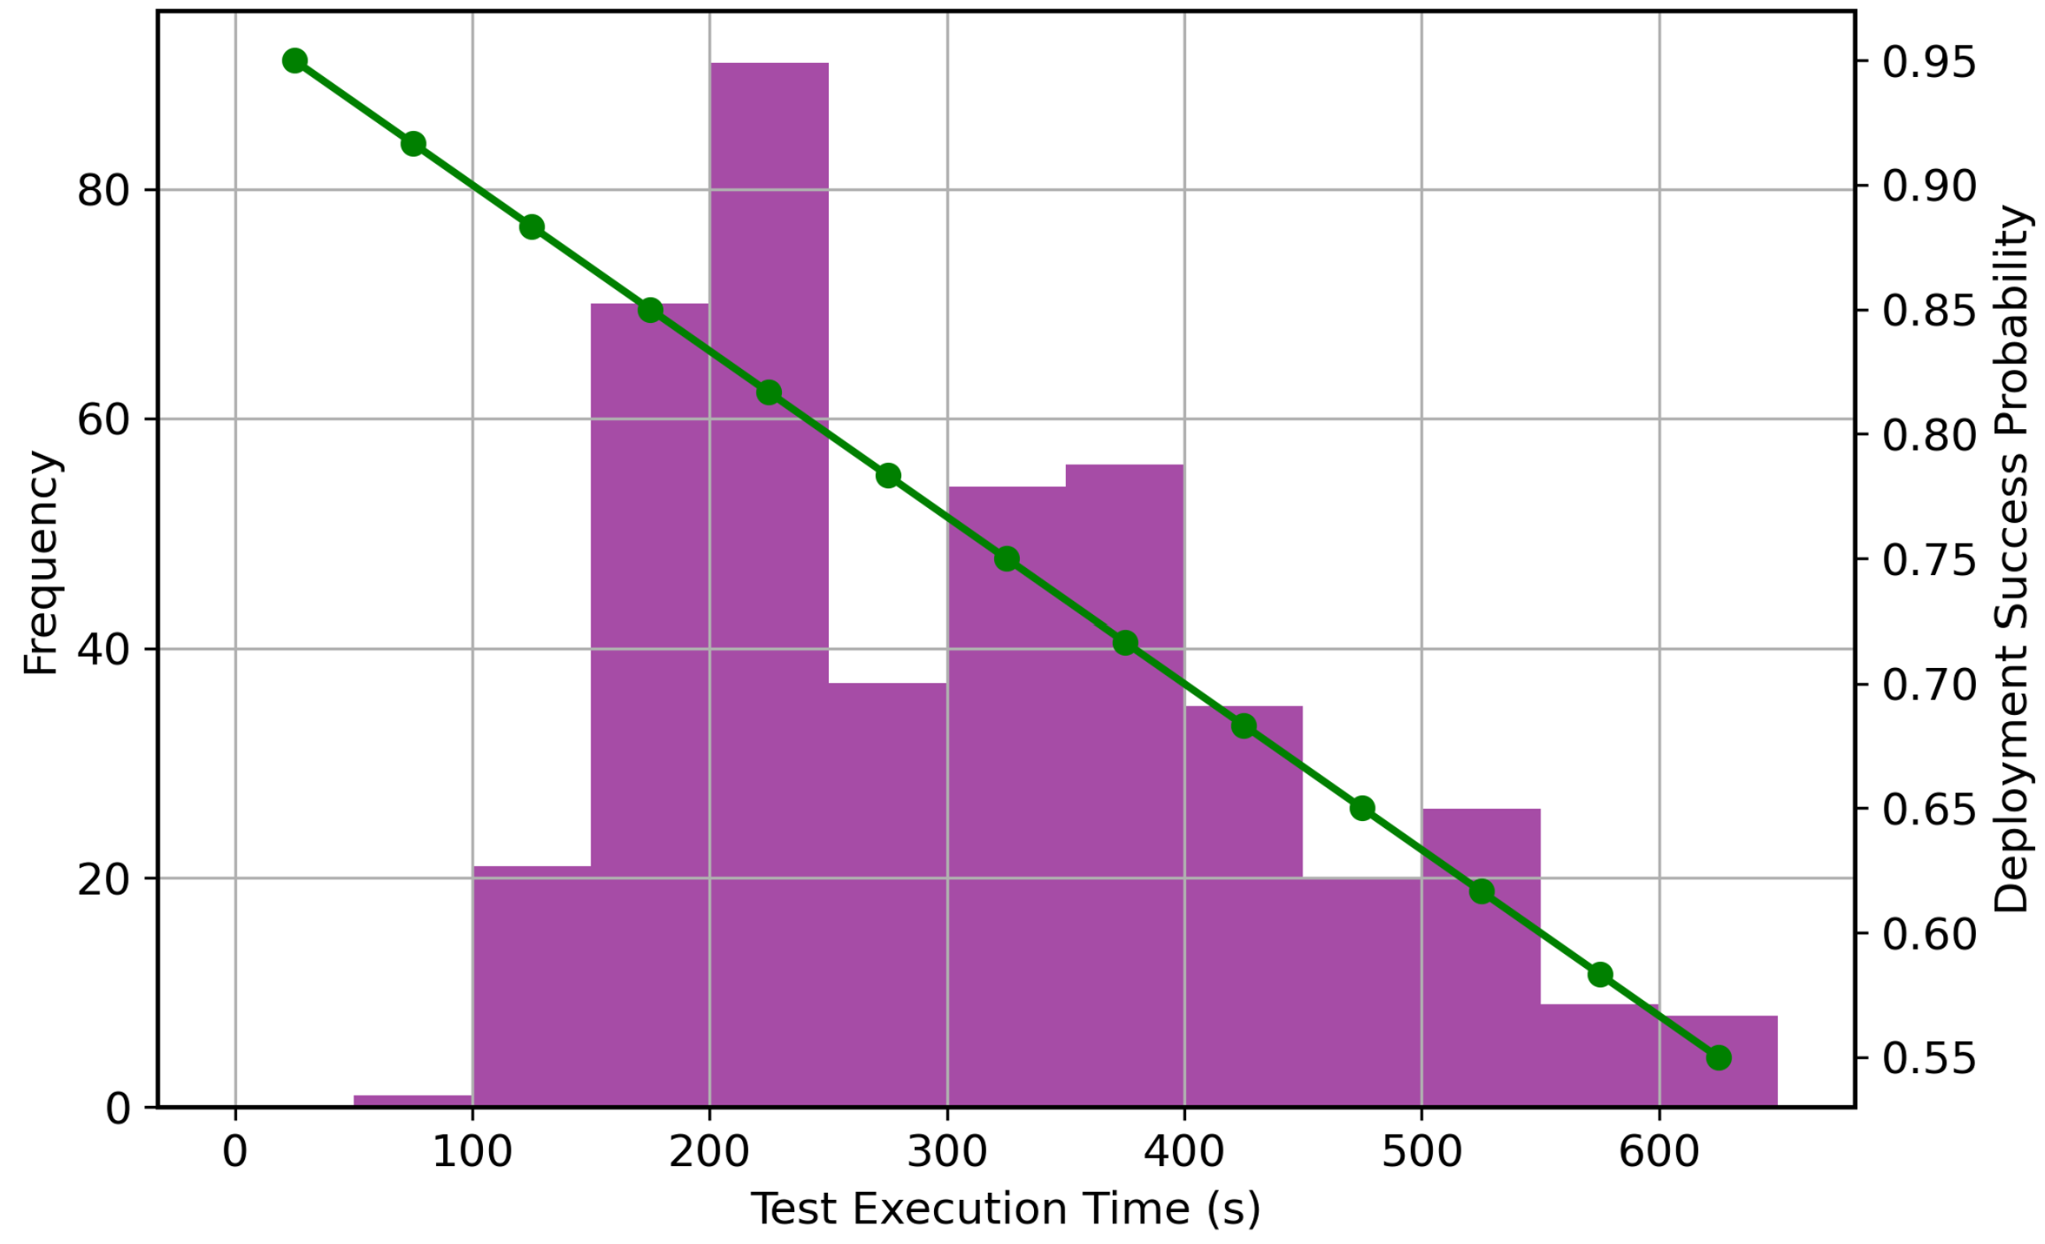
Fig. 3. Representation of the frequency of test execution.
Fig. 3 presents a combined histogram of test execution time frequency and the overall deployment success rate. The bars show the number of builds in specific time buckets, and the line crossing the bars shows the likelihood of deployment success. An obvious trend is apparent; the deployment frequency starts to fall sharply as the test execution time shifts to the upper buckets. This graph shows the break-even point at which pipeline performance begins to slow the delivery speed. By combining these two data types into a single graph, it is possible to perform a correlation analysis that is easily overlooked when reviewing individual dashboards. F1 score for model accuracy evaluation in math form will be
$F_{1}=2⋅\frac{\text{Precision}⋅\text{Recall}}{\text{Precision}+\text{Recall}}$ (5)
Mean Absolute Error (MAE) for time-series prediction
$MAE=\frac{1}{n}\sum_{i=1}^{n}{∣}y_{i}-{\hat{y}}_{i}∣$ (6)
The system's quantitative accuracy rate was 94, and the false-positive rate was very low at 2.1. It is a very important measure because when the false-positive level is high, the engineers disregard warnings. The conclusions also revealed a significant correlation between resource consumption and build time, suggesting that most of the anomalies were in fact due to contention on the underlying infrastructure. These infrastructure-related problems can be separated by the AI model, allowing the DevOps team to focus on the more effective targets of their troubleshooting. In general, the findings affirm that the use of AI in pipeline metrics is a far more sensitive and consistent safety net than the traditional approach.

DISCUSSIONS
The tables and graphs present a comprehensive perspective on the transformation of pipeline monitoring enabled by AI. The days between instances 201 and 300 were evidently deviant, as indicated in Table 1. Classical monitoring would have raised alarms about the single errors, whereas the AI model could account for the high resource load and the increased time required to determine the root cause. Such insight is much more useful than an alert on a building failure, since the engineering team can be directed to the infrastructure rather than the code. This is further supported by the swarm chart in Figure 2, which indicates that these events are not mere noise but clear groups of problematic behaviour that need to be addressed.
Table 2 is probably the most informative part of the study. The fact that recall rose by 0.50-0.93 shows that almost half of all pipeline problems were not detected using the old approaches. These unnoticed problems are the silent killers of the introduction- the issues that do not halt the construction but rather slow the group down. The ensemble model offers a far narrower safety net by capturing these. The human factor in the data is also evident in the mixed histogram in Fig. 3 as pipelines slow, deployment decreases. The reason is probably that developers grow impatient with slow feedback, bundle their changes, and end up with more risky launches and a higher risk of failure.
Moreover, the data indicate that the AI models are highly robust to the pipeline's natural fluctuations. The average duration is constant in Table 1, although the maximum duration varies. This would indicate that the artificial intelligence is effectively weeding out the usual, acceptable deviations in the manufacturing time and attempting to isolate the actual anomalies. It is this difference that minimizes alert fatigue. When each small spike triggers a notification, engineers will start ignoring them. The system guarantees a high precision rate, meaning that when an alarm is triggered, it is highly likely to indicate an issue that requires human attention. In the end, the discussion results indicate that pipeline metrics are closely related. It is impossible to consider build duration in a vacuum; it must be considered in relation to resource usage and test execution time. The multidimensional perception of AI enables it to generate a more complete view of health, much more accurate than an individual indicator. This paper demonstrates that AI usage in CI/CD indicators is not only about identifying mistakes but also about providing better insight into the software delivery factory and ensuring it operates at peak capacity.

REFERENCES
- W. Hilal, S. A. Gadsden, and J. Yawney, “Financial fraud: a review of anomaly detection techniques and recent advances,” Expert Systems with Applications, vol. 193, p. 116429, 2022.
- X. Ma, J. Wu, S. Xue, J. Yang, C. Zhou, Q. Z. Sheng, et al., “A comprehensive survey on graph anomaly detection with deep learning,” IEEE Transactions on Knowledge and Data Engineering, vol. 35, no. 12, pp. 12012–12038, 2021
- A. A. Mir, M. F. Zuhairi, and S. M. Musa, “Graph anomaly detection with graph convolutional networks,” International Journal of Advanced Computer Science and Applications, vol. 14, no. 11, 2023.
- K. Pei, T. Huang, W. Ipenburg, and M. Pechenizkiy, “ResGCN: attention-based deep residual modeling for anomaly detection on attributed networks,” Machine Learning, vol. 111, no. 2, pp. 519–541, 2022.
- K. Qin, Y. Zhou, B. Tian, and R. Wang, “AttentionAE: autoencoder for anomaly detection in attributed networks,” in Proc. 2021 Int. Conf. Networking and Network Applications (NaNA), 2021, pp. 480–484.
- H. Fan, F. Zhang, and Z. Li, “AnomalyDAE: dual autoencoder for anomaly detection on attributed networks,” in Proc. IEEE Int. Conf. Acoustics, Speech and Signal Processing (ICASSP), 2020, pp. 5685–5689.
- W. Khan, M. Haroon, A. N. Khan, M. K. Hasan, A. Khan, U. A. Mokhtar, et al., “DVAEGMM: dual variational autoencoder with Gaussian mixture model for anomaly detection on attributed networks,” IEEE Access, vol. 10, pp. 91160–91176, 2022.
- H. Boye, “Strengthening cloud security through advanced encryption and anomaly detection techniques for secure data storage and transmission,” FMDB Transactions on Sustainable Computer Letters, vol. 2, no. 3, pp. 153–163, 2024.
- R. Wang, F. Zhang, X. Huang, C. Tian, L. Xi, and H. Fan, “CACO: attributed network anomaly detection via canonical correlation analysis,” IEEE Transactions on Industrial Informatics, vol. 20, no. 1, pp. 461–470, 2023.
- K. Ding, J. Li, R. Bhanushali, and H. Liu, “Deep anomaly detection on attributed networks,” in Proc. SIAM Int. Conf. Data Mining, 2019, pp. 594–602.
- H. Kim, B. S. Lee, W.-Y. Shin, and S. Lim, “Graph anomaly detection with graph neural networks: current status and challenges,” IEEE Access, vol. 10, pp. 111820–111829, 2022.
- D. Dobos, T. T. Nguyen, T. Dang, A. Wilson, H. Corbett, J. McCall, et al., “A comparative study of anomaly detection methods for gross error detection problems,” Computers & Chemical Engineering, vol. 175, p. 108263, 2023.
- Z. Xu, B. Wang, Z. Zhao, H. Lin, and F. Xia, “Unsupervised anomaly detection on attributed networks with graph contrastive learning for consumer electronics security,” IEEE Transactions on Consumer Electronics, vol. 70, no. 1, pp. 4062–4072, 2024.

